1. The aboveground biomass data was from Fig. 37(page 136)

Data was from Peak biomass of Shallow and Deep for MUL, PIN, PRT and RIV.

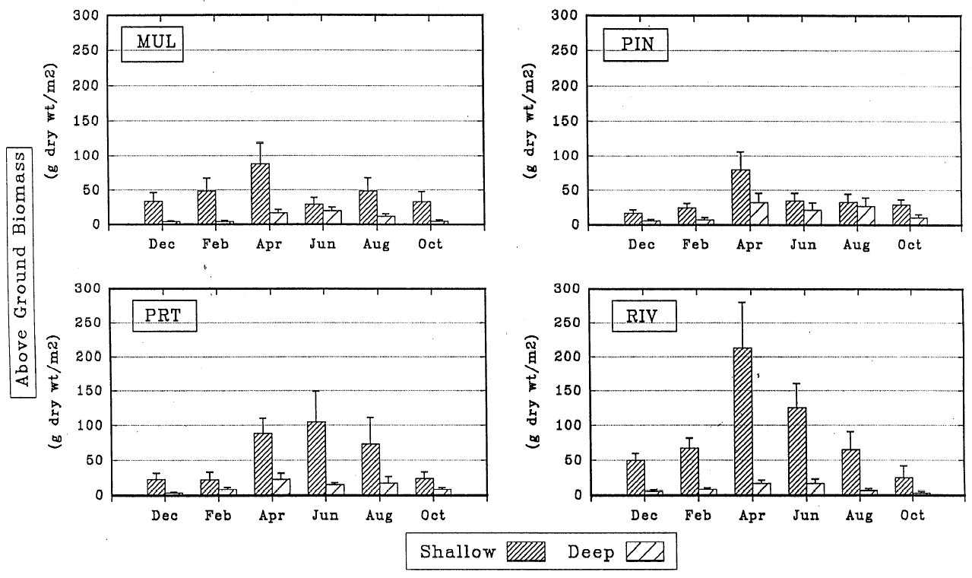

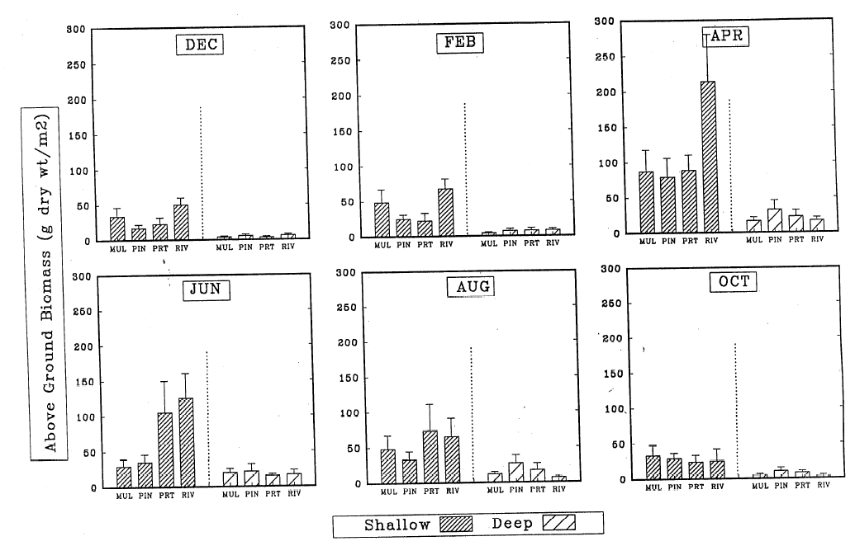

2. The belowground biomass mass was calculated by aboveground biomass and Shoot:Root ratio (Fig. 39)

